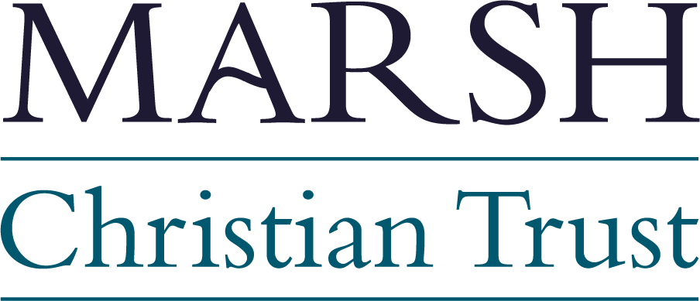
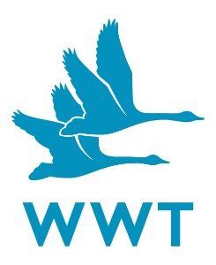
Marsh Awards for Wetland Conservation Achievement & Impact
Nomination form 2018
Creating, restoring and protecting wetlands has never been more vital. Understanding the threats faced by the wildlife they support and engaging everyone from governments to families in doing what it takes to conserve the species and places we love is an ongoing challenge. Having inspirational examples of what can be achieved is crucial in the fight we face and the WWT Marsh Awards for Wetland Conservation are your chance to nominate someone who you feel is just that.
Use this form to tell us about the individual you most admire and the impact they’ve had on wetland conservation. For the first time this year we’ll be offering two awards;
- The Marsh Award for Wetland Conservation Achievement – for an individual who sustained activities have resulted in a long term change for wetlands or their wildlife
- The Marsh Award for Wetland Conservation Impact – for an individual who has achieved something amazing for wetlands over the last 12 months.
A panel will choose the very best and WWT will give those people the award and a cheque for one thousand pounds at our AGM this October.
It might be an unsung hero who has been quietly looking after a wetland area in a park or green space like so many do across the country with all of the benefits that brings. It could be someone who has spent their life on research aimed at protecting wetlands and their wildlife. Perhaps there has been an activity to engage people around the world with wetlands over the last 12 months that stands out and you feel an individual behind it is worthy of commendation.
The only rules are that it has to be an individual who is nominated even if they worked through an organisation and they have to have done something worth celebrating for wetlands. Please use this form to make the best case you can for your chosen nominee and we’ll come back to you if we feel more information is needed.
- All applications need to be made to Rebecca Jordan and received by 31st May
- Martin Spray CBE (WWT Chief Executive), Alastair Driver (WWT Trustee and Director of Rewilding Britain) and a representative of the Marsh Christian Trust will meet by the end of July to decide on the winners, with everyone who nominates informed of their decision shortly afterwards
- The presentation will be made on 11th October at the WWT AGM at Slimbridge
Nominee’s name:

Place, Project or Research Associated with them:

Award nominated for:

Your name:

Your position /organisation (if applicable):
Your email address:

Your telephone number:

Please describe in no more than 300 words, why you feel the individual is deserving of this award:

Please include any links to additional information in support of the application here:

Thank you for taking the time to nominate!
Nominations must be returned to Rebecca Jordan no later than Thursday 31st May 2018.
rebecca.jordan@wwt.org.uk or WWT Slimbridge, Glos, GL2 7BT

