Wetland Centre birthday party booking form
Date
Child’s name and age
Contact name and number
Contact email
Additional activity (please select one only). A guided tour and hand-feeding of the birds is already included, bird seed free of charge. | Pond dipping (March-Oct)
 | Fun and games (all year)
 | Den building (March-Oct, minimum age 5-years-old)
 | Creative arts and crafts (all year)
Number of children
Number of adults
(one adult free per paying child, additional adults pay normal admission)
Food (optional)
Number of kids’ boxes (sandwich, crisps, cookies, juice, sweets, £4.10 each)
Coffees and teas may be bought on the day from our cafe.
Any special requirements/needs that we should be aware of?
I have received and agree to terms and conditions (see next page)
(party organiser, please sign)
Keeping in touch
We would like to keep you up to date about what’s happening at our centres, our conservation work and ways you can support us. We are committed to keeping your personal information secure and we will never share it with other organisations for marketing purposes.
Please tick the relevant boxes below if you are happy to hear from us by:
E-mail Telephone SMS
You can change your contact preferences at any time by contacting our Supporter Services team on 01453 891198 or supporter@wwt.org.uk
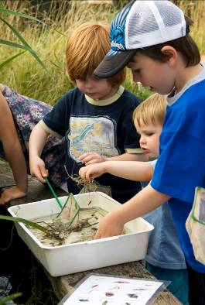 |  | 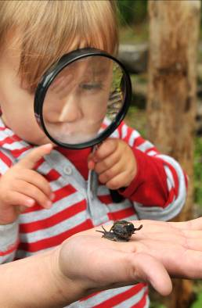
We think our birthday parties are one-of-a-kind
but don’t just take our word for it...
“Awesome birthday party; professional, energetic and fun staff” – Adrian’s mam
“Lovely party, entertaining and educational” – Elizabeth’s mam
“Smooth and well organised; a wonderful party experience” – Eva’s mam
Thank you for booking your birthday party at WWT Washington Wetland Centre.
We look forward to seeing you!
Terms and conditions
- A £100 non-refundable deposit is required at time of booking, with the final balance payable on the day of the party.
- 10 children minimum, 25 children maximum. We find this is the perfect group size for everyone to have a great time!
- In the event of adverse weather conditions, WWT Washington reserves the right to substitute activities where first choice is unfeasible. So don’t worry your party will go ahead whatever the weather.
- By booking, party organisers agree that their party will respect the wildlife, collection birds and other visitors at all times during their visit. After all you’re here because you love wildlife as much as we do!
- Each child must be accompanied by an adult during the party; our fun is family based and inclusive.
- Guests are welcome to remain on site after the party, to explore and enjoy the centre and its grounds (normal closing times apply – 4.30pm in winter and 5.30pm in summer).
The Wildfowl & Wetlands Trust, registered charity in England & Wales no. 1030884 and Scotland no. SCO39410.

