Access Statement

WWT Martin Mere Wetland Centre
Fish Lane, Burscough L40 0TA

A visual story of the centre is available to either download from the website or to request a copy when you arrive at the centre.

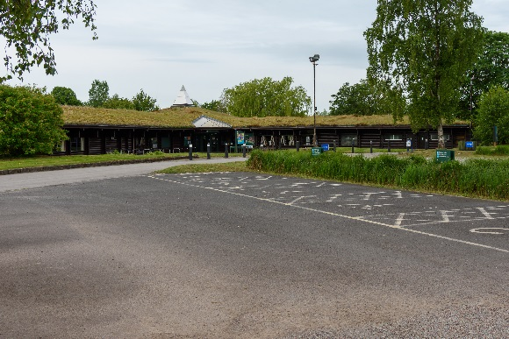
The car park
It is free to park vehicles at Martin Mere.

There are two large blue badge holder car parks catering for 20 vehicles. One of the sections is tarmacked whilst the other is stoned. These car parks are located within 15 metres of the main entrance over a sloped paved walkway.

Arrival
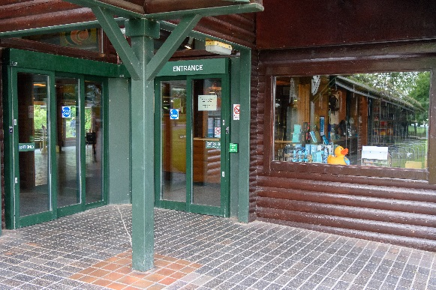
There is a push button to open the main entrance doors which is is 90cm above the ground and the door opens to a width of 118cm. Upon entry the admissions desk height is 74cm. The admissions area and whole building has level access.

The exit doors back to the car park are automatic opening.

Free wheelchairs are available at the centre and these can be requested on arrival or in advance by emailing info.martinmere@wwt.org.uk. It is free for carers to enter the centre.

A Walkabout guide is available to purchase at the entrance at a cost of £3.50 and it contains pictures of all of the birds we have on our site. Day planners are also available from the information desk that contain a map to help you find your way around and a summary of what to see during your visit. A ‘whats on’ board provides you with the full schedule of talks and activities.

Hearing
We have a hearing loop available in the main foyer and the lecture theatre.

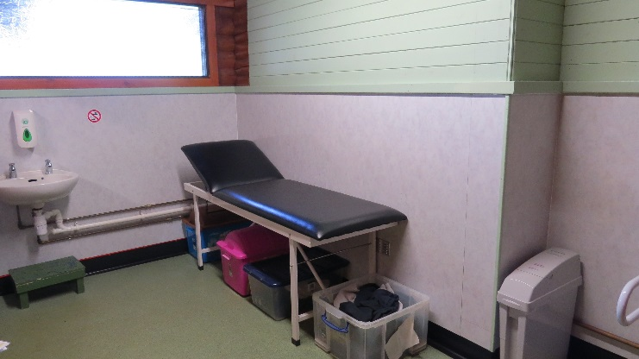
Toilets
All toilets have motion centred lighting installed. There are accessible toilets available in the following locations:
- In Mere Side Café
- Next to the play area
- At the canoe safari (compost toilets)
- On the nature trail opposite the Raines Observatory
- Main corridor of the building: this includes a bench which is 70cm in height to allow for adult changing. This toilet does not have a hand dryer.

The building
The building houses an exhibition hall, retail shop, lecture theatre and classrooms. There is also an indoor picnic space that is open during the school holidays and at weekends. There is a craft room that is open at the weekend and during holidays offering a range of free and paid crafts. Trays are available to request from the craft room for visitors in a wheelchair who would like to have a go at the crafts. All areas are accessible for wheelchair users. There are large windows in the main foyer and exhibition hall for ease of movement in building for visitors with a visual impairment. Our shop staff will be happy to assist anyone who is unable to reach the higher shelves. The retail payment point is 99cm in height with a lower option available at a height of 74cm.

Upon exiting the building to the waterfowl gardens, all doors are double doors and need to be manually pushed open. The widths of the individual doors are 80cm (minimum) to 90cm (maximum).

Mere Side Café
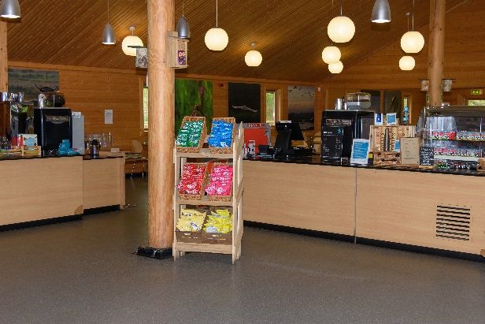
The café is located next to the main building, leaving via the door by the exhibition hall.
The entrance and exit doors are controlled by push buttons that are 85cm above the ground.

Menus are in large text on the walls in contrasting colours.

Meals are ordered at the counter at a height of 90cm and the food is delivered to your table. Cash as well as card payments are accepted. There are ten baby chairs available as well as a microwave to heat up baby food. Free water is provided. We cater for sugar free (diabetic), vegetarian and gluten free (celiacs) specific diets, although it is worth contacting the café in advance to inform us of any specific dietary requirements by emailing info.martinmere@wwt.org.uk or calling 01704 891220.

There are large windows along the right hand side of the café to assist with visual impairment. The table and plates have contrasting colours

There is an outdoor seating area overlooking swan lake. This is accessible via a sliding door in the café and has a non slip floor surface externally. Our café staff will be happy to assist anyone who needs support in carry trays, drinks and condiments.

The waterfowl gardens

The waterfowl gardens are all fully paved and accessible with benches at regular intervals as resting points. There are steel gates separating the themed waterfowl zones which are manually opened.

Guided boat tours are available from the canoe safari location. The boat can accommodate two wheelchairs. It is recommended to either pre-book your boat trip or enquire on arrival as they do get fully booked in busy periods. The path leading to the boat tours is stoned. There is no minimum age for the boat tours. The minimum age for the canoe safari is 5 years old. Boat tours close from November to March.

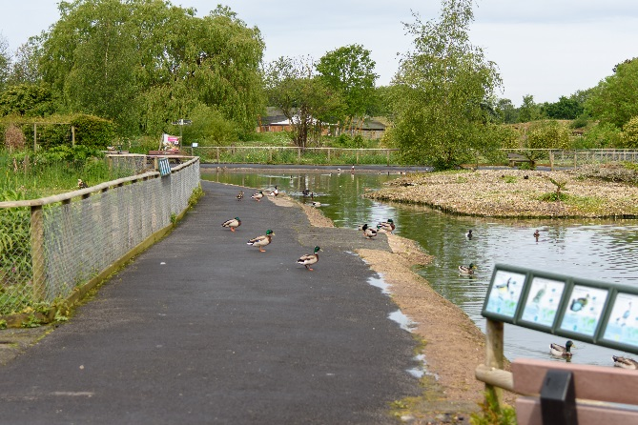
Items to note in the waterfowl gardens:
- The gardens have lots of open space and pathways are next to open water
- The eco-garden leads to the white stork enclosure which is accessed via a ramp that has non-slip mesh on it.
- The central part of the eco-garden is pathed but there is a wooded area that has bark chippings over it and can become muddy in wet conditions.
- Wild Walk is located off the Africa area in the grounds. Wooden boards are used as a pathway leading to the central ‘middle lodge’. There are 2 steps leading from the lodge that leads to wobbly bridges, balancing beams and stepping stones. Away from the path, Wild Walk can become very muddy in wet conditions and busy periods.
- There is an aviary located in the WOW development. The aviary is accessible through doors that can be easily pushed open. The birds in the aviary can take flight and will often fly onto the roof of the aviary building.
- There are three locations in the grounds that have hand dryers – outside the café, the Wooded Wetlands area and the WOW area by the aviary – all dryers are located within a wooden housing structure.

The pond zone is the latest attraction to open at WWT Martin Mere. It is DDA compliant and is accessible for anyone wanting to have a go at finding small creatures in the ponds. Minimum age for the pond dipping is 2.

There are large gates from the waterfowl gardens to the nature trail and these steel gates are self-closing but can make a noise when closing.

The nature trail

The nature trail is fully paved. It is not a circular loop. Most of our hides have lower windows to allow for wheelchair users to view the wildlife. Listed below are the heights of these windows as well as door widths and key accessible information. Some of the hides can appear to be dark.

Hide | Distance from centre | Door width | Window height for wheelchairs | Access notes
Discovery hide | 15 metres | Main entrance is 90 cm (180cm with double doors). Three other doors 83 cm | 60 cm (inside)  110 cm (outside wing) | Hide is DDA compliant
In focus binocular shop | 40m | Two doors both 88cm | Glazed look out windows at 78 cm | One level, fully accessible. Best place to go to find out about the latest sightings
Gladstone hide | 240m | 120 cm outside door leads to 93 cm inside door | 100cm | There is a small lookout area at the back of the hide that is accessible via steps.
Janet kear hide | 490m | 87 cm outside door leads to 73 cm inside door | 100cm | Ideal for watching bird feeders. There are entry points at both sides of the hide that are accessible via two doors, as there is a central raised area accessed via steps.
Harrier hide | 490m | 3 upstairs doors are 75 cm. There is a wooden lip on the door frames. | Central floor to ceiling windows to view the wildlife. | There is a steep slope leading up to the Harrier Hide
United Utilities hide | 585m | 144cm | 95cm | Wheelchair users will need assistance to enter hide as there is a steep sloped pathway. The top level is only accessible via a set of stairs.
Raines Observatory | 160m | All doors are 90cm | 80cm | Heated observatory with bench seating. Sliding and push doors to enter.
Hale hide | 215m | 80cm | 100cm | One level, fully accessible
Kingfisher hide | 480m | 94cm | There are no lower windows in this hide due to concrete structure. | There are two entrances to this hide – one a set of stairs whilst the second is a sloped pathway
Ron Barker hide | 585m | 85cm | 85cm | Two levels. The top level is only accessible via a small number of stairs.

There are two ‘lookout’ points along the nature trail overlooking the mere. These are accessed via a small slope.
There is a reedbed walk accessible from the lower level of the Harrier Hide. This walk is approximately 45 minutes and would not be suitable for wheelchairs. The entrance to the reedbed walk has two 80 cm doors which lead to a 75 cm door.

Customer care support

- In the event of a fire alarm, all visitors inside the attraction will be led to safety by a member of the team to the designated fire evacuation point.
- Only guide and assisted dogs are allowed in the grounds. We can provide a water bowl for them on request. The nearest toilet for assisted dogs is located within the car park next to the entrance gates.
- On our website, within the accessibility area, you will find a visual story of our building and facilities to download – or you can request a colour print out when you arrive at the centre.

Morning Explorers: Relaxed times to visit the centre

At Martin Mere, during mid-week term time, the centre is quiet enough to welcome anyone who may struggle with crowds or have a sensory overload – this includes people with autism and dementia.

At the weekends we recommend visiting between 9.30am and 11.30am when the centre is more relaxed. There will be no queues at the entrance and the building and café will not be noisy.

Activities during morning explorers:

- Call in advance for your own guided boat tour, reserved specifically for children or adults with additional needs. The guided boat tours are 20 minutes in duration and the boat floats along at 3mph giving you the opportunity to get up close to nature. The boat tours are an additional £3 per seat. The boat tours run at 10.30am and 11am. The boat can accommodate 2 wheelchairs. The boat tours are only available from April to end of October.

Please note that during school holidays and bank holidays the centre is a lot busier than normal and these relaxed times are only recommended during school term time.

