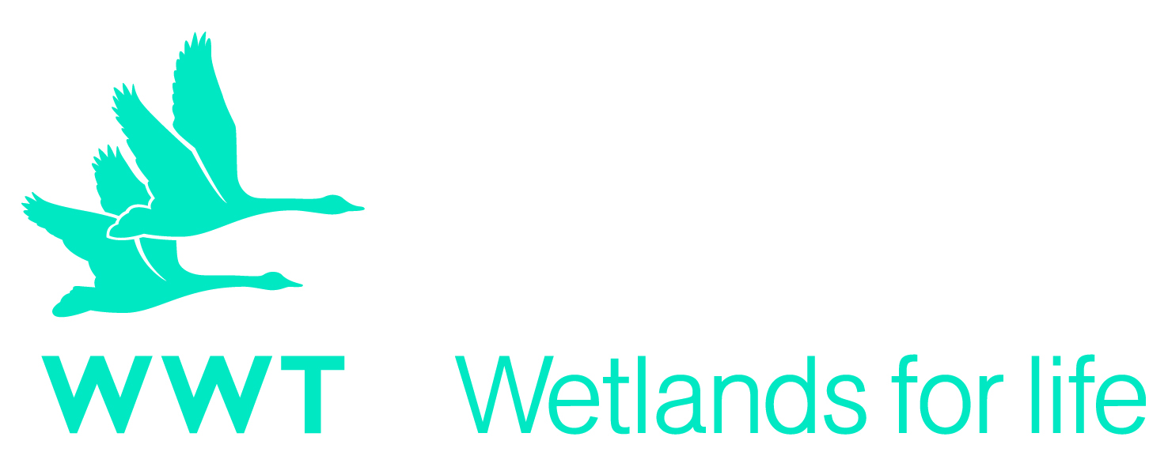
E-mail:
wli@wwt.org.uk

Return Application to:
Post:
Amy Hannon,
VDO,
Wildfowl & Wetlands Trust (WWT)
Slimbridge
Glos GL2 7BT
UK

WWT application for the International Engagement internship

Personal details

Surname |  |  | Dr/Mrs/Miss/Ms/Mr/Other
Forename

Address

 |  |  | Post code
Home telephone number
Alternative telephone number
Email address |  |  | (please specify)
Home Address

 |  |  | Post code
University

Degree

Please note that all correspondence will be sent via email.

Qualifications
(List the qualifications you have taken and are currently taking. Give details and grades. (E.g. first year of degree results).

Level of qualification | Subject | Result

Training courses
(Detail any specific training you have received or any relevant short courses attended)

Membership of professional organisations
(Detail below membership of any technical or professional bodies or societies)

Spare time interests and vocational activities

Current or last employment details / educational institution

Company name and address

Position held

Duration in post (months/years)

Final or most recent salary and benefits

Outline present duties / key achievements)

Past employment/volunteering details (excluding your current or last position)
(if you are applying for your first post after leaving school or further education, please indicate any past holiday employment)

Employers name | Job title / key duties | Salary | Dates from and to and duration in post (months/years) | Reason for leaving

Why are you interested in applying for this post?

Relevant experience (no more than 2 sides of A4)

Do you require a work permit? Yes No

If yes, do you hold a current permit? Yes No

References

Please give the names of two referees below. One should normally be your present or most recent employer. References will not be taken up prior to interview unless you are notified otherwise.
Name, address and telephone number | Position
1.

2.

Data protection statement

WWT uses information collected in this form to process your application. WWT will handle your data in accordance with the requirements set out in the General Data Protection Regulation and the Data Protection Act 2018. Further information about how we use your personal data is set out in our Privacy Policy: http://www.wwt.org.uk/volunteering/privacy-policy/

Physical ability

Do you require any aids or adaptations to carry out the duties of the post? (a disability will not preclude you from full consideration for employment with WWT), if so please specify.

Please tell us how you learned about this internship

