Washington Wetland Centre birthday party booking form

Date of party
Child’s name and age
Contact name and number
Contact email
Additional activities (please select one activity from the options below)
Pond dipping (March-Oct)
Mini-beast safari and mirror walk (6 years +)
Den building (March-Oct, minimum age 5 years +)
Creative arts and crafts (all year)
A guided tour and hand-feeding of the birds is already included, bird seed free of charge.
Number of children (including birthday child)
Number of adults
(one adult free per paying child, any additional adults pay normal admission)
Bringing own snacks OR
Number of WWT kids boxes – choice of sandwich (ham, cheese or jam), crisps, yoghurt, chocolate bar, drink £4.50 each.
Coffees and teas may be bought on the day from our cafe.
Any special requirements/needs that we should be aware of?
I have received and agree to terms and conditions (see next page)
(party organiser, please sign)
Contact
For any queries, please call Joanne Newbury on 0191 419 5933 or email joanne.newbury@wwt.org.uk
Keeping in touch
We would like to keep you up to date about what’s happening at our centres, our conservation work and ways you can support us. We are committed to keeping your personal information secure and we will never share it with other organisations for marketing purposes.
Please tick the relevant boxes below if you are happy to hear from us by:
E-mail Telephone SMS
You can change your contact preferences at any time by contacting our Supporter Services team on 01453 891198 or supporter@wwt.org.uk
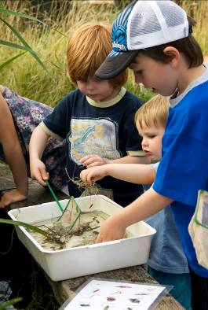 | 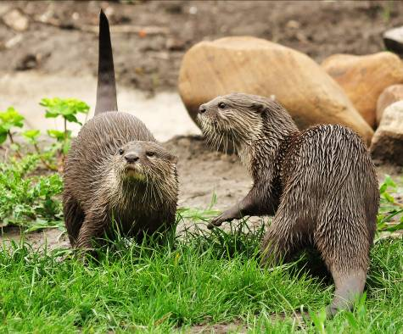 | 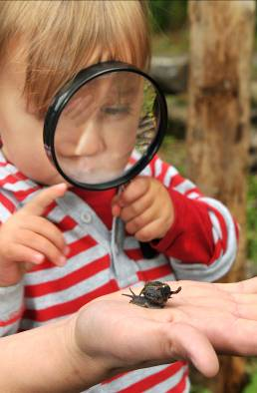

We think our birthday parties are one-of-a-kind but don’t just take our word for it...

“Awesome birthday party; professional, energetic and fun staff” – Adrian’s mam
“Lovely party, entertaining and educational” – Elizabeth’s mam
“Smooth and well organised; a wonderful party experience” – Eva’s mam
Thank you for booking your birthday party at WWT Washington Wetland Centre.
We look forward to seeing you!

Terms and conditions
- A £100 non-refundable deposit is required at time of booking, with the final balance payable on the day of the party.
- Each child must be accompanied by an adult during the party; our fun is family based and inclusive.
- 10 children minimum, 25 children maximum. We find this is the perfect group size for everyone to have a great time!
- In the event of adverse weather conditions, WWT Washington reserves the right to substitute activities where first choice is unfeasible. So don’t worry your party will go ahead whatever the weather!
- By booking, party organisers agree that their party will respect the wildlife, collection birds and other visitors at all times during their visit. After all, you’re here because you love wildlife as much as we do!
- Guests are welcome to remain on site after the party, to explore and enjoy the centre and its grounds (normal closing times apply – 4.30pm in winter and 5.30pm in summer).

- Parties take place in our education barn, just opposite the play area.

