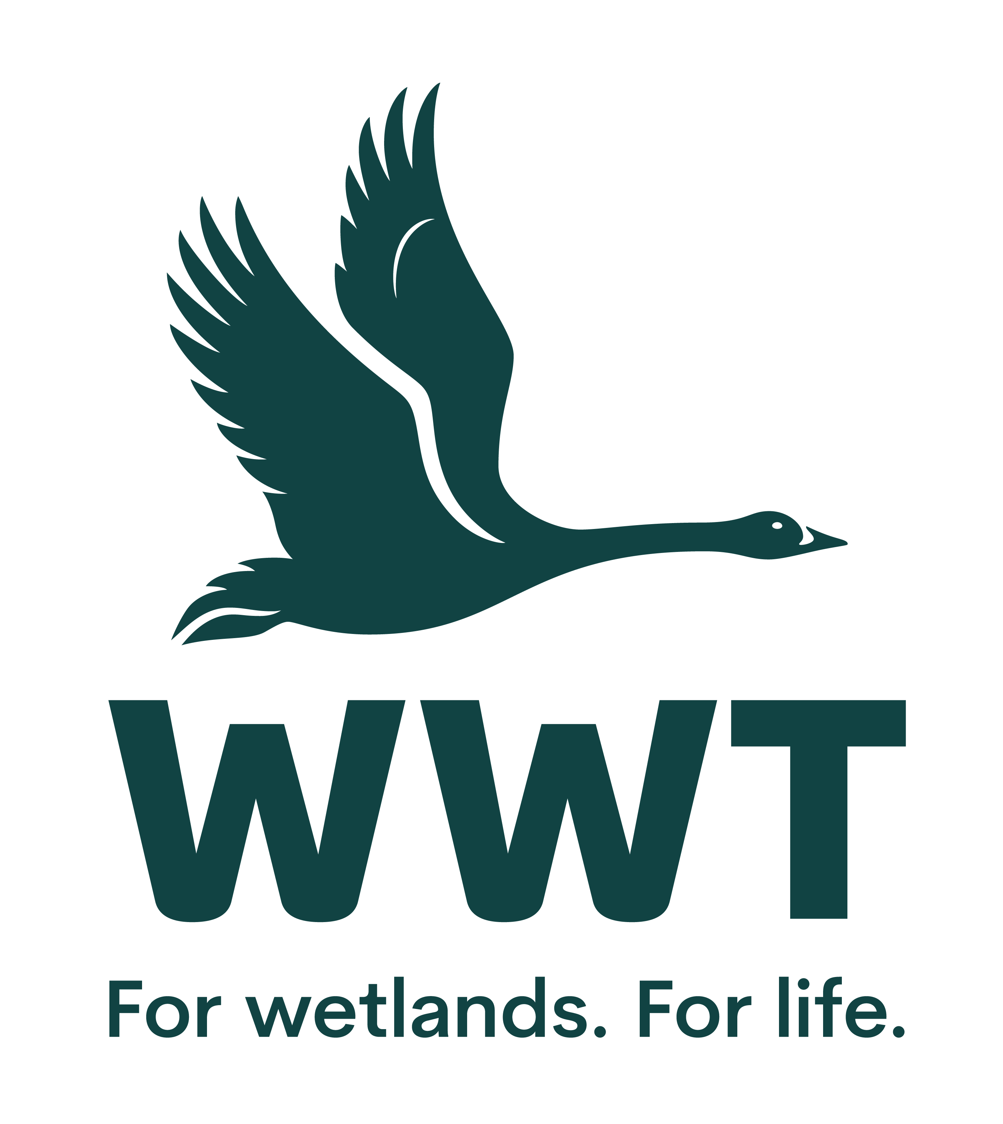
VOLUNTEER OPPORTUNITY: Retail Volunteer
Why do we need you?
At WWT we shape unforgettable experiences. We are a warm, welcoming and genuine charity that protects and restores Wetlands. WWT Martin Mere has 600 acres of amazing wetland scenery which is home a such an assortment of wildlife.
We are looking for volunteers who can support our team in our Café and shop to ensure we offer excellent customer service to our visitors.
By providing excellent customer care in our shop, you will be encouraging our visitors to support the wider conservation work of WWT. The money that is taken in retail is instrumental to the conservation work that WWT can afford to carry.
Volunteers play a crucial role in saving wetlands for wildlife and people.

Who will be responsible for your role? Retail, admissions and membership manager
Where will you be based? WWT Martin Mere Wetland Centre
How much time will it take? We will mutually agree the hours that you can contribute.
What will you be doing?
- Help provide a warm, friendly welcome to all visitors, answering queries about Martin Wetland Centre and shop products.
  - Assist with merchandising the shop and receiving deliveries.
- Process sales and take customer payments through the till.
- Promote the benefits of WWT membership and sign-up new members using a computer system.
  - Help keep the shop floor clean and tidy to best present products and ranges.
  - Attend daily briefings or read daily updates to keep up to date with developments across the centre

Who are we looking for?
This role would suit you if:
- Have an enthusiastic and friendly manner
- Have an eye for detail and creativity
- Excellent verbal communication skills
- A confident attitude and / or experience in successful face-to-face contact with the public
- Commitment to excellent customer service
- Are happy using a computer/till
- Like working in a busy environment
- An interest in birding and optics equipment (if you’d like to get involved in promoting and selling our optics)

How will you benefit?
- This is an excellent opportunity to volunteer at an internationally important wetland site
- You’ll be part of a friendly and dedicated team with plenty of opportunities to meet new people and make new friends
- An induction will be provided as well as other training opportunities
- Free entry to all our sites across the country
- Discount is available in the café and the shop on the day of volunteering
- Relevant training opportunities will be provided

General notes:
We regret that we are not in a position to reimburse travel expenses; however pre-agreed, out of pocket expenses incurred in the course of your volunteering activities will be reimbursed in line with WWT’s expenses policy. We regret that we are not in a position to reimburse expenses incurred for travel to Martin Mere where you will be based.
You will need to be able to get yourself to and from Martin Mere.
This position is entirely voluntary and is therefore unpaid. Any offer of a volunteer placement is not intended to create a legally binding contract between us and any agreement may be cancelled at any time at the discretion of either party. Neither of us intends any employment relationship to be created either now or at any time in the future.
Date raised: 15.12.23

